A Real-Time Research Project Report
on

RAILWAY CRACK, TRACK AND OBSTACLE DETECTION SYSTEM
Submitted in partial fulfillment of the requirements for the award of the degree of
Bachelor of Technology
in

COMPUTER SCIENCE AND ENGINEERING (AI & ML)

by
T. Vaishnavi [247R1A66B8]
K. Srigna [247R1A6684]
G. Ruthvik [247R1A6679]
CH. Saketh Reddy [247R1A6675] Under the guidance of
R. Lavanya
Assistant Professor



DEPARTMENT OF COMPUTER SCIENCE AND ENGINEERING (AI & ML)

CMR TECHNICAL CAMPUS UGC AUTONOMOUS
Accredited by NBA & NAAC with ‘A’ Grade Approved by AICTE, New Delhi and JNTU Hyderabad
Kandlakoya(V), Medchal Road, Hyderabad – 501401April, 2026

DEPARTMENT OF COMPUTER SCIENCE AND ENGINEERING (AI&ML)



CERTIFICATE
This is to certify that the Real-Time Research Project Report entitled RAILWAY CRACK, TRACK AND OBSTACLE DETECTION SYSTEM being submitted by T. Vaishnavi [247R1A66B8] K. Srigna [247R1A6684] G. Ruthvik [247R1A6679] Ch. Saketh Reddy [247R1A6675] in partial fulfillment of the requirements for the award of the degree of Bachelor of Technology in COMPUTER SCIENCE AND ENGINEERING (AI & ML) to the Jawaharlal Nehru Technological University, Hyderabad is a record of Bonafide work carried out by them under my guidance and supervision during the Academic Year 2025 – 26.
The results embodied in this report have not been submitted to any other University or Institute for the award of any other degree.

R. Lavanya Dr. S Rao Chintalapudi
Assistant Professor Head of the Department Project Guide

ACKNOWLEDGEMENT

Apart from the efforts of us, the success of any project depends largely on the encouragement and guidelines of many others. We take this opportunity to express our gratitude to the people who have been instrumental in the successful completion of this project.
We take this opportunity to express my profound gratitude and deep regard to my guide R. Lavanya for her exemplary guidance, monitoring and constant encouragement throughout the project work. The blessing, help and guidance given by her shall carry us a long way in the journey of life on which we are about to embark. We are also thankful to Dr. S Rao Chintalapudi, Head, Department of Computer Science and Engineering (AI&ML) for providing encouragement and support for completing this project successfully. We are obliged to Dr. A. Raji Reddy, Director for being cooperative throughout the course of this project. We also express our sincere gratitude to Sri. Ch. Gopal Reddy, Chairman for providing excellent infrastructure and a nice atmosphere throughout the course of this project. The guidance and support received from all the members of CMR Technical Campus who contributed to the completion of the project. We are grateful for their constant support and help. Finally, we would like to take this opportunity to thank our family for their constant encouragement, without which this assignment would not be completed. We sincerely acknowledge and thank all those who gave support directly and indirectly in the completion of this project.

T. VAISHNAVI [247R1A66B8]
K. SRIGNA [247R1A6684]
G. RUTHVIK [247R1A6679] CH. SAKETH REDDY [247R1A6675]

Table of Contents

Chapter Title | Page No
Abstract | iv
List of Figures | v
1. Introduction
1.1 Motivation | 1
1.2 Problem Statement | 1
1.3 Project Objective | 1
2. Literature Survey
2.1 Existing System | 2
2.2 Disadvantages of Existing System | 2
2.3 Proposed System | 2
2.4 Advantages of Proposed System | 2
2.5 Conclusion | 3
3. Requirement Specification
3.1 Software Requirements | 5
3.2 Hardware Requirements | 5
3.3 Functional Requirements | 6
3.4 Non-Functional Requirements | 6
4. System Design

4.1 System Design | 7
4.2 Proposed Methodology | 9
4.3 UML Design | 10
4.3.1 Class Diagram | 11
4.3.2 Use Case Diagram | 11
4.3.3 Component Diagram | 12
4.3.4 Sequence Diagram | 13
4.3.5 Activity Diagram | 14
5. Implementation
5.1 Implementation | 15
5.2 Modules | 15
6. Testing
6.1 Testing Definition | 19
6.2 Test Cases | 22
7. Results | 24
8. Conclusion | 26
9. Future Scope | 27
10. References | 28

ABSTRACT
Railway accidents are a major concern, often caused by track cracks, discontinuities, and obstacles. Traditional inspection methods rely on manual monitoring, which is time-consuming and prone to human error. These limitations increase the risk of accidents and reduce overall efficiency. Hence, there is a need for an automated and reliable detection system.
This project proposes an Arduino-based Railway Crack, Track, and Obstacle Detection System. IR sensors are used to detect cracks and discontinuities in the railway track, while an ultrasonic sensor is used to identify obstacles. The system continuously monitors the track conditions in real time. This ensures faster detection and improved safety.
The Arduino microcontroller processes the sensor data and takes necessary actions. When any fault is detected, the system automatically stops the train motor to prevent accidents. At the same time, a buzzer alert is activated to provide an immediate warning. This reduces human intervention and enhances system reliability.
The proposed system is cost-effective, efficient, and easy to implement. It provides continuous monitoring compared to existing methods and improves railway safety significantly. The system can be further enhanced using IoT, GPS tracking, and AI technologies. Thus, it serves as a practical solution for modern railway safety systems.

LIST OF FIGURES

S. No | Figure Name | Page No
Figure 4.1 | System Architecture of Railway Crack Detection System | 12
Figure 4.2 | Proposed Methodology | 13
Figure 4.3.1 | Class Diagram for Railway Crack Detection System | 14
Figure 4.3.2 | Use Case Diagram for Railway Crack Detection System | 15
Figure 4.3.3 | Component Diagram for Railway Crack Detection System | 16
Figure 4.3.4 | Sequence Diagram for Railway Crack Detection System | 17
Figure 4.3.5 | Activity Diagram for Railway Crack Detection System | 18
Figure 5.1 | Implementation Setup | 21
Figure 7.1.2 | Output – Obstacle Detection | 29

- INTRODUCTION

MOTIVATION
The motivation behind this project arises from the limitations of existing surveillance systems and the growing need for smarter, more efficient monitoring solutions. In many urban areas, fixed CCTV cameras fail to provide complete coverage, especially in dynamic or crowded environments. Additionally, installing and maintaining wired surveillance infrastructure can be expensive and time-consuming.
There is also an increasing demand for systems that can operate in hazardous or hard-to-reach areas where human monitoring is difficult or unsafe. The integration of IoT and robotics provides an opportunity to design systems that are mobile, intelligent, and capable of real- time communication.
This project aims to leverage these technologies to create a surveillance system that is not only efficient but also adaptable to different environments. By reducing human intervention and enabling remote monitoring, the system contributes to improved safety and smarter city management.

PROBLEM STATEMENT
The existing railway track inspection system mainly depends on manual checking or periodic monitoring using specialized equipment. While these methods provide basic safety measures, they suffer from several limitations:
- Lack of real-time monitoring
- High dependency on human inspection
- Increased chances of human error
- Time-consuming and inefficient process
- High cost of advanced inspection systems
- Delay in detecting cracks and obstacles
Due to these limitations, the current system is not sufficient to ensure complete safety in modern railway networks. There is a need for an automated system that can continuously monitor railway tracks and provide immediate alerts in case of any fault.

PROJECT OBJECTIVE
The main objective of this project is to design and develop an automated railway safety system that can detect cracks, track discontinuities, and obstacles in real time. The system aims to

improve safety, reduce accidents, and minimize human intervention. The specific objectives of the project include:
- To detect cracks in railway tracks using IR sensors
- To detect obstacles using ultrasonic sensors
- To monitor track conditions continuously in real time
- To automatically stop the train motor when a fault is detected
- To generate immediate alerts using a buzzer
- To develop a cost-effective and reliable safety system
- To improve overall railway safety and efficiency

LITERATURE SURVEY

Existing Railway Track Monitoring Systems
Railway track monitoring is traditionally carried out through manual inspection by railway personnel or by using specialized inspection vehicles. These methods involve periodic checking of tracks to identify cracks, misalignments, and other defects. Although such systems provide basic safety measures, they are not capable of offering continuous real-time monitoring.
Manual inspection is highly dependent on human observation and experience, which increases the chances of errors. In addition, covering long railway tracks requires significant time and manpower. As a result, faults may remain undetected for extended periods, leading to potential accidents. Therefore, existing systems lack efficiency, reliability, and real-time response.

Sensor-Based Detection Systems
With the advancement of embedded systems, sensor-based detection methods have been introduced to improve railway safety. These systems use sensors such as Infrared (IR) sensors, ultrasonic sensors, and vibration sensors to detect cracks and obstacles.
IR sensors are commonly used to identify discontinuities in railway tracks by detecting changes in reflected signals. Ultrasonic sensors help in detecting obstacles by measuring the distance between the sensor and the object. These technologies enable automated detection and reduce dependency on manual inspection.
However, many existing sensor-based systems are either complex or expensive, limiting their widespread adoption. There is still a need for a simple, cost-effective, and efficient solution.

Arduino-Based Embedded Systems
Arduino-based systems have gained popularity due to their simplicity, flexibility, and low cost. Many researchers have used Arduino microcontrollers to design railway safety systems that integrate multiple sensors for real-time monitoring.
In such systems, the Arduino acts as the central processing unit, collecting data from sensors and making decisions accordingly. When a fault is detected, the system can trigger alerts or control actuators such as motors. These systems are easy to implement and suitable for educational and practical applications.

The use of Arduino significantly reduces system complexity while maintaining efficiency and reliability, making it an ideal choice for this project.

Automated Railway Safety Systems
Automated railway safety systems aim to minimize human intervention by using intelligent monitoring and control mechanisms. These systems continuously monitor track conditions and respond immediately when a fault is detected.
Some advanced systems include features such as automatic train control, remote monitoring, and integration with communication networks. These systems improve safety and reduce response time, but they often require high investment and complex infrastructure.
The proposed project focuses on developing a simplified version of such systems using basic components while maintaining effectiveness.

Challenges in Existing Systems
Despite technological advancements, several challenges still exist in railway safety systems:
- Lack of continuous real-time monitoring
- High implementation and maintenance cost
- Dependence on stable power and infrastructure
- Environmental factors affecting sensor performance
- Limited accessibility in remote areas
These challenges highlight the need for a system that is affordable, reliable, and capable of operating efficiently under different conditions.

Cost-Effective and Practical Solutions
Recent research emphasizes the importance of developing low-cost and practical solutions for railway safety. Systems built using affordable components such as Arduino, IR sensors, and ultrasonic sensors provide a balance between performance and cost.
Such systems are easy to install, maintain, and scale according to requirements. They can be deployed in both urban and rural areas, making them suitable for widespread implementation. The simplicity and effectiveness of these systems make them a promising solution for improving railway safety.

Conclusion
The literature survey highlights the evolution of railway track monitoring systems from manual inspection to automated sensor-based solutions. While existing systems provide certain advantages, they also suffer from limitations such as high cost, lack of real-time

monitoring, and dependency on human intervention.
The study of various technologies, including sensors and embedded systems, provides valuable insights for designing an efficient solution. The proposed Arduino-based Railway Crack, Track, and Obstacle Detection System aims to overcome these limitations by providing a reliable, cost-effective, and real-time monitoring system, thereby enhancing overall railway safety.

REQUIREMENTS SPECIFICATION
This chapter describes the hardware and software requirements needed for the development and implementation of the Railway Crack, Track, and Obstacle Detection System. It also explains the functional and non-functional requirements that define the behavior and performance of the system.

SOFTWARE REQUIREMENTS
The software components play an important role in controlling the system and enabling communication between hardware modules.

🔹 Programming Language
- Embedded C – Used to program the Arduino microcontroller and control all hardware operations such as sensor input processing and motor control.

🔹 Development Tools
- Arduino IDE – Used for writing, compiling, and uploading code to the Arduino board. It provides an easy interface for development and debugging.

🔹 Operating System
- Windows / Linux – Used for developing and uploading the program to the microcontroller.

🔹 Simulation Tools (Optional)
- Proteus / Tinkercad – Used for circuit simulation and testing before actual hardware implementation

HARDWARE REQUIREMENTS
The hardware components form the physical system used for detection and control.
- Arduino Uno – Acts as the main controller of the system, processing sensor inputs and controlling outputs.
- IR Sensors – Used to detect cracks and discontinuities in railway tracks.
- Ultrasonic Sensor – Used to detect obstacles present on the track.
- Motor Driver (L298N) – Controls the movement and direction of the motor.
- DC Motor – Represents the movement of the train.
- Buzzer – Provides an alert signal when a fault is detected.

- Power Supply – Provides necessary power to all components.
These components work together to form an automated railway safety system.

FUNCTIONAL REQUIREMENTS
Functional requirements describe the main operations and capabilities of the system.
- The system should detect cracks in railway tracks using IR sensors.
- The system should detect obstacles using an ultrasonic sensor.
- The system should continuously monitor track conditions in real time.
- The system should stop the motor automatically when a fault is detected.
- The system should generate an alert using a buzzer.
- The system should process sensor data accurately using the Arduino controller.
- The system should operate without human intervention.

NON-FUNCTIONAL REQUIREMENTS
Non-functional requirements define the quality and performance aspects of the system.
- Performance: The system should respond quickly to faults with minimal delay.
- Reliability: The system should function continuously without failure.
- Accuracy: Sensors should provide accurate detection of cracks and obstacles.
- Cost Efficiency: The system should be low-cost and affordable.
- Scalability: The system should allow future upgrades and enhancements.
- Maintainability: The system should be easy to maintain and repair.
- Usability: The system should be simple to operate and understand.

SYSTEM DESIGN

System Design
In this phase, the overall design of the Railway Crack, Track, and Obstacle Detection System is developed based on the requirement specifications. This phase is crucial as it defines the system architecture, components, and workflow required for effective operation. The design ensures proper integration of hardware components such as sensors, microcontroller, motor, and alert system.
The system is designed as an embedded system that uses sensor technology and a microcontroller to perform real-time monitoring of railway tracks. The architecture is divided into three main parts: input unit, processing unit, and output unit.
The input unit consists of IR sensors and an ultrasonic sensor. The IR sensors are used to detect cracks or discontinuities in the railway track by sensing variations in reflected infrared signals. The ultrasonic sensor is used to detect obstacles by measuring the distance between the sensor and the object using sound waves.
The processing unit consists of the Arduino Uno microcontroller. It acts as the brain of the system, receiving data from the sensors and processing it according to the programmed logic. Based on the sensor inputs, the Arduino decides whether the track condition is normal or faulty.
The output unit includes the DC motor and buzzer. The motor represents the movement of the train. When no fault is detected, the motor runs normally. If any crack or obstacle is detected, the Arduino sends a signal to stop the motor immediately. At the same time, the buzzer is activated to alert about the fault.

The system is designed to operate continuously in a loop, ensuring real-time monitoring and immediate response. This design improves reliability, reduces human intervention, and enhances overall railway safety.

System Architecture

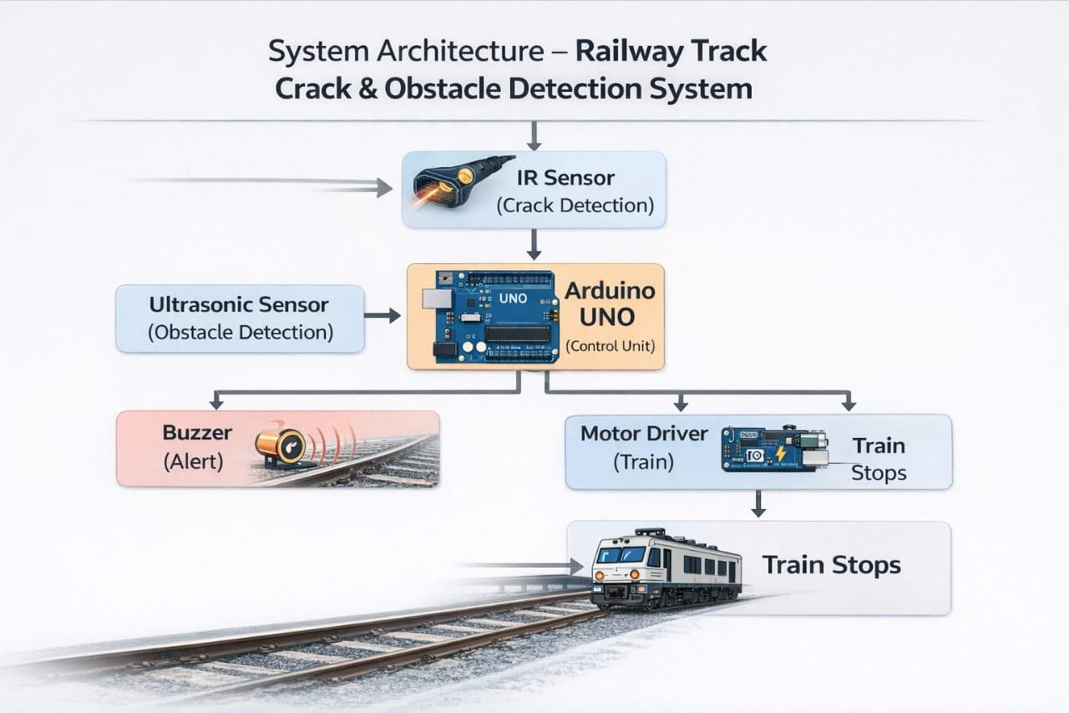
Figure 4.1:system architecture

PROPOSEDMETHODOLOGY
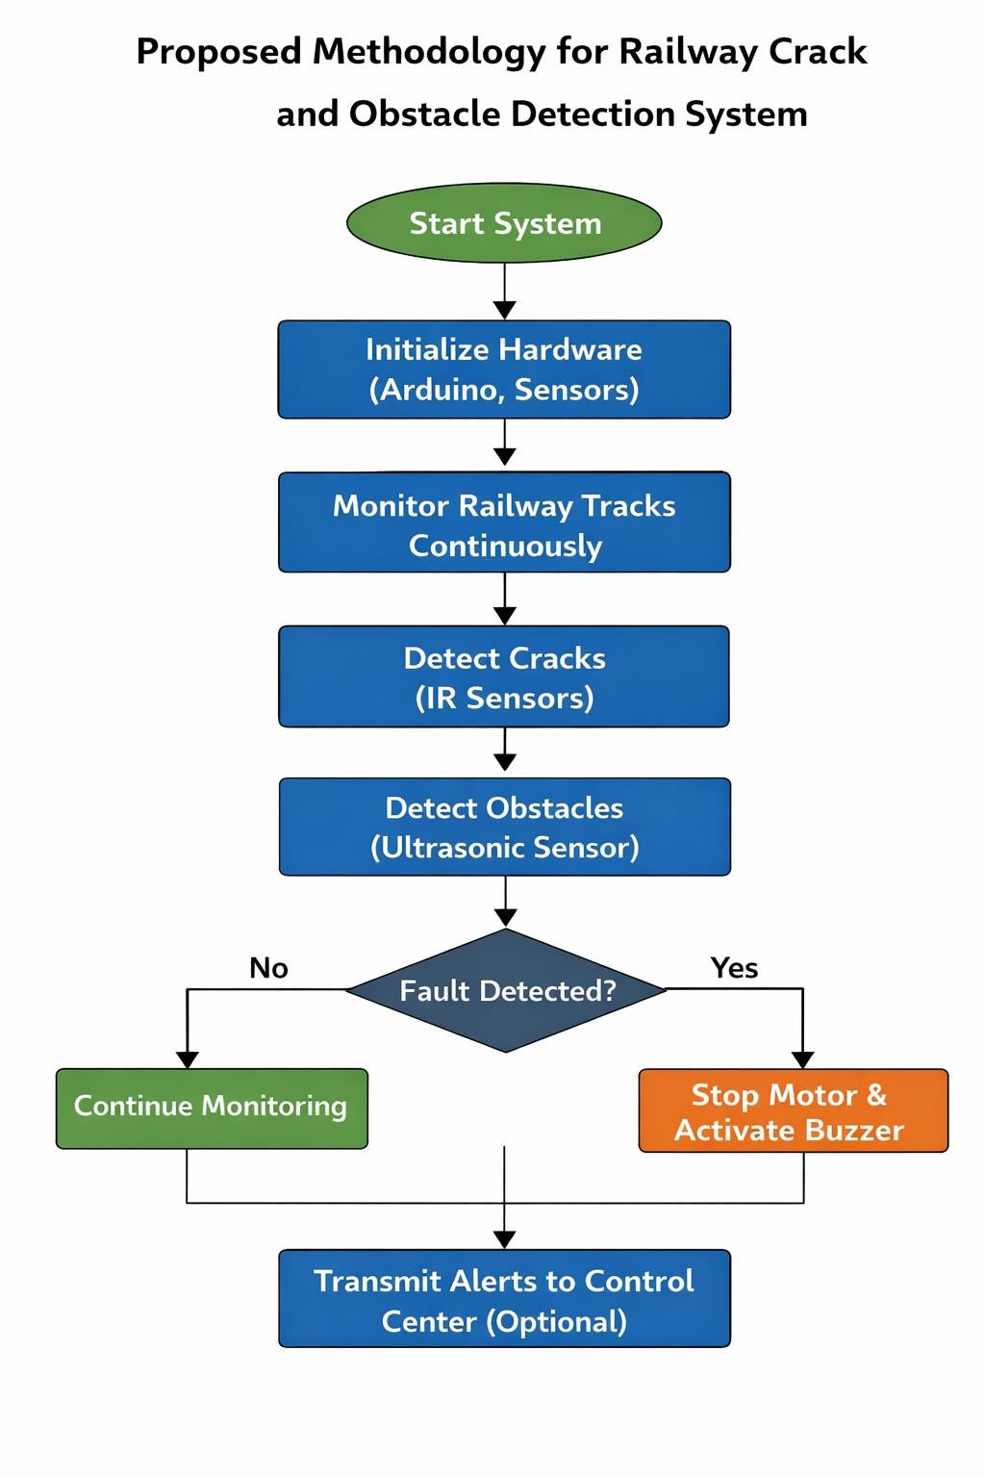
Figure 4.2:proposed methodology

UML DESIGN

Unified Modeling Language (UML) is used to represent the structure and behavior of the system. It helps in visualizing the system components and their interactions.

CLASS DIAGRAM

The class diagram represents the static structure of the system by showing different classes and their relationships. The main classes in this system include Sensor, Arduino Controller, Motor, and Buzzer.
Each class has its own attributes and methods. For example, the Sensor class includes attributes for detection and methods for sending data. The Arduino class processes inputs and controls outputs. This diagram helps in understanding how different components are organized in the system.
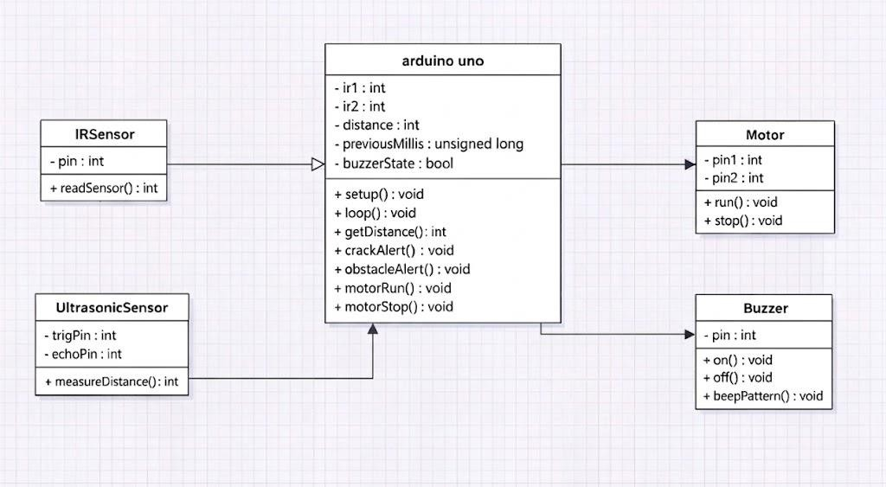

Fig 4.3.1: Class diagram

USE CASE DIAGRAM

The use case diagram illustrates the interaction between the user and the system. The main actor in this system is the user or operator.

The use cases include monitoring track conditions, detecting cracks, detecting obstacles, and receiving alerts. This diagram provides a clear understanding of system functionalities from the user’s perspective.
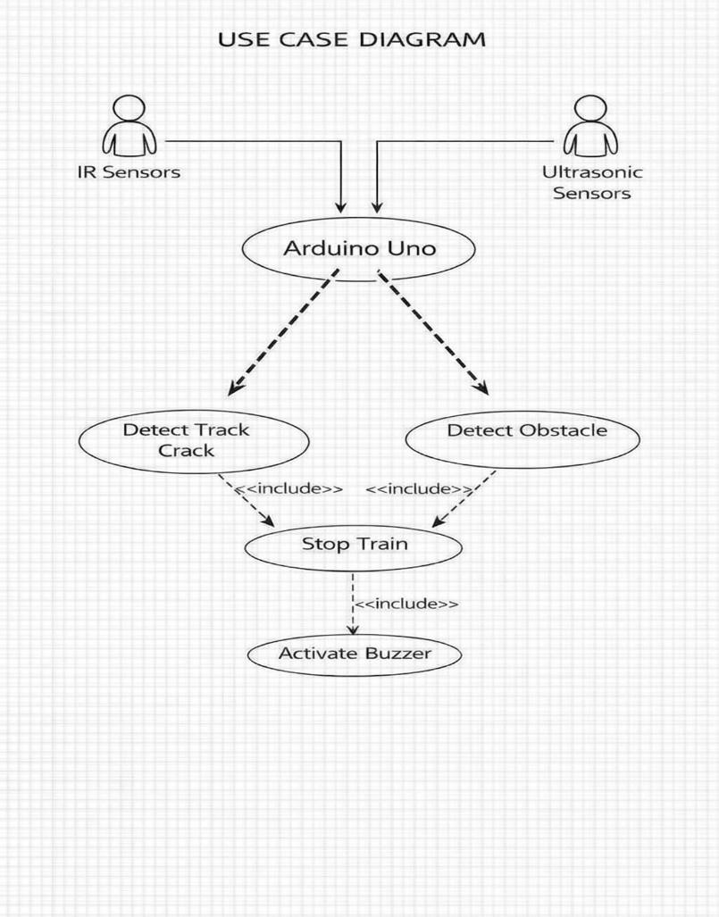

Fig 4.3.2 : Use Case Diagram

COMPONENT DIAGRAM

The component diagram shows the high-level components of the system and their interactions. The main components include the sensor module, Arduino controller, motor module, and alert system.
This diagram explains how different hardware components are connected and how they work together to achieve the system objectives.

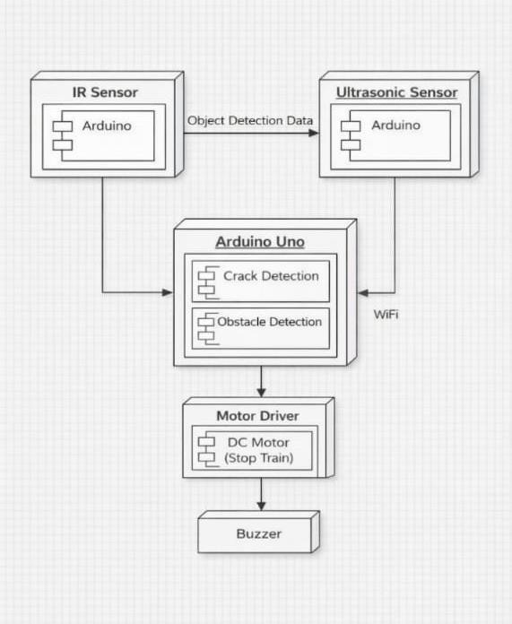

Fig 4.3.3: component diagram

SEQUENCE DIAGRAM

The sequence diagram represents the flow of communication between system components over time. It shows how data is transmitted from sensors to the Arduino and how the Arduino sends control signals to the motor and buzzer.
This diagram helps in understanding the sequence of operations performed during fault detection.

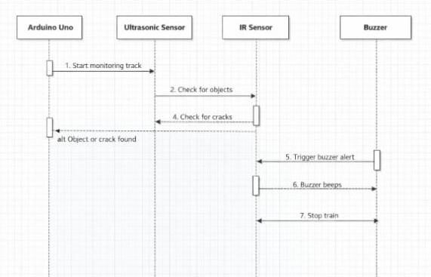
Fig 4.3.5: Sequence Diagram

ACTIVITY DIAGRAM

The activity diagram describes the workflow of the system. It shows the sequence of activities such as monitoring track conditions, detecting faults, processing data, and generating alerts.
This diagram provides a step-by-step representation of system operation.

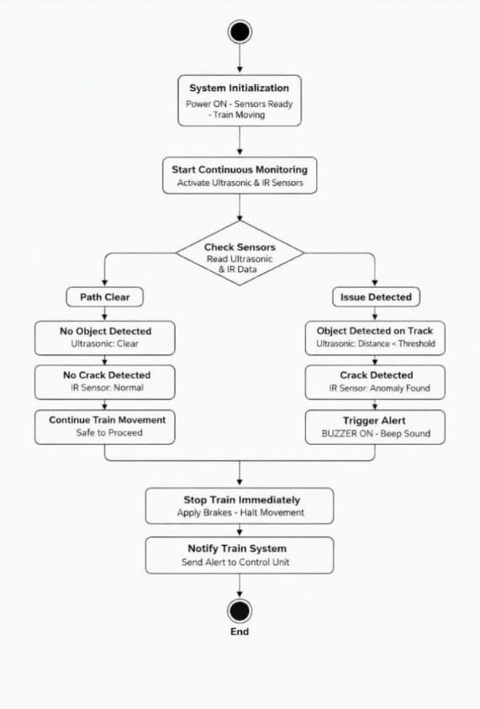
Fig 4.3.6: Activity Diagram

Technology Description
The Railway Crack, Track, and Obstacle Detection System is developed using a combination of embedded systems, sensor technology, and basic automation techniques to ensure efficient and reliable railway track monitoring. The integration of these technologies enables real-time detection of faults and improves overall safety.
The system primarily uses embedded system technology, where the Arduino Uno microcontroller acts as the central processing unit. It is responsible for receiving input signals from sensors, processing the data, and controlling the output components such as the motor and buzzer. The Arduino is programmed using Embedded C through the Arduino IDE, which allows efficient control and execution of system operations.

The system incorporates sensor technology to detect faults in railway tracks. Infrared (IR) sensors are used to detect cracks or discontinuities in the track by analyzing the reflection of infrared light. When there is a break or gap in the track, the reflected signal changes, which is detected by the sensor and sent to the microcontroller. Additionally, an ultrasonic sensor is used to detect obstacles on the track. It works by emitting ultrasonic waves and measuring the time taken for the echo to return, thereby calculating the distance of any object present.
For movement representation and control, the system uses DC motors along with a motor driver (L298N). The motor driver acts as an interface between the Arduino and the motor, allowing control over speed and direction. When no fault is detected, the motor runs normally. If a crack or obstacle is detected, the Arduino sends a signal to stop the motor immediately.
The system also includes an alert mechanism using a buzzer. When a fault is detected, the buzzer is activated to provide an immediate warning signal. This helps in alerting nearby personnel and preventing accidents.
The entire system operates on a power supply unit, which provides the necessary voltage to all components. The design ensures low power consumption and efficient performance.
Overall, the combination of embedded systems, sensors, motor control, and alert mechanisms enables the development of a cost-effective, reliable, and real-time railway safety system. This technology can be further enhanced by integrating advanced features such as IoT, GPS tracking, and wireless communication for improved monitoring and control.

IMPLEMENTATION

IMPLEMENTATION
The implementation of the Railway Crack, Track, and Obstacle Detection System involves the integration of hardware components and software programming to achieve real-time monitoring and fault detection. The system is designed using Arduino as the main controller, along with sensors and output devices to perform detection and alert operations.
Initially, all hardware components such as the Arduino Uno, IR sensors, ultrasonic sensor, motor driver, DC motor, and buzzer are assembled and connected properly. The IR sensors are placed near the railway track model to detect cracks or discontinuities. The ultrasonic sensor is positioned to detect obstacles in front of the track.
The Arduino microcontroller is programmed using the Arduino IDE with Embedded C. The program includes logic for continuously reading sensor data, analyzing the inputs, and taking necessary actions based on the detected conditions. The system operates in a continuous loop to ensure real-time monitoring.
During operation, the IR sensors continuously check for any break or crack in the track. If a discontinuity is detected, the sensor sends a signal to the Arduino. Similarly, the ultrasonic sensor measures the distance of any object present on the track. If an obstacle is detected within a predefined range, the sensor sends the data to the Arduino.
Based on the sensor inputs, the Arduino processes the information and determines whether the track condition is safe or faulty. If no fault is detected, the DC motor continues to run normally, representing the movement of the train. If a crack or obstacle is detected, the Arduino immediately stops the motor to prevent accidents.
At the same time, a buzzer is activated to provide an alert signal indicating the presence of a fault. This ensures that the system responds quickly and effectively to any abnormal condition. The entire system operates automatically without the need for human intervention, making it efficient and reliable.

MODULES
The system is divided into several modules, each responsible for a specific function:

Sensor Module
The sensor module is responsible for detecting cracks and obstacles. It consists of IR sensors and an ultrasonic sensor. The IR sensors detect cracks by sensing changes in infrared reflection, while the ultrasonic sensor detects obstacles by measuring distance. The data collected is sent to

the Arduino for processing.

Control Module
The control module consists of the Arduino Uno microcontroller, which acts as the brain of the system. It receives input from sensors, processes the data, and controls the output devices. It ensures proper coordination between all modules.

Motor Module
The motor module includes the DC motor and motor driver. It is responsible for the movement of the system. The motor runs under normal conditions and stops immediately when a fault is detected.

Alert Module
The alert module consists of a buzzer that provides an audio signal when a crack or obstacle is detected. It helps in notifying users about potential danger.

Power Supply Module
This module provides the required electrical power to all components. It ensures stable operation of the system.

TESTING

TESTING DEFINITION:

Testing is an important phase in system development that ensures the system works correctly and meets the specified requirements. It involves executing the system with the intention of identifying errors, verifying functionality, and ensuring reliability.
In the Railway Crack, Track, and Obstacle Detection System, testing is performed to ensure that all components such as sensors, microcontroller, motor, and buzzer operate correctly. It verifies whether the system can accurately detect cracks and obstacles and respond appropriately.
Different types of testing are carried out to ensure complete functionality and performance of the system.

Unit Testing

Unit testing focuses on testing individual components or modules of the system independently. Each module is tested to ensure it performs its function correctly.
- IR Sensor Testing: Verifies detection of cracks and discontinuities

- Ultrasonic Sensor Testing: Ensures accurate obstacle detection

- Motor Testing: Checks proper movement and stopping mechanism

- Buzzer Testing: Ensures alert is generated correctly

Integration Testing

Integration testing is performed by combining different modules to verify their interaction. It ensures that data flows correctly between sensors, Arduino, and output devices.

System Testing

System testing evaluates the complete system to ensure it meets all functional requirements. It

verifies real-time detection, motor control, and alert generation.

Test Objectives

- Ensure accurate detection of cracks and obstacles

- Verify proper functioning of all hardware components

- Ensure immediate response to faults

- Validate system reliability and performance

Features to be Tested

- Crack detection using IR sensors

- Obstacle detection using ultrasonic sensor

- Motor stopping mechanism

- Buzzer alert system

- Continuous monitoring capability

Test Results

All the test cases were executed successfully. The system performed as expected under normal conditions. The sensors accurately detected faults, and the motor stopped immediately when a fault was identified. The buzzer alert was also triggered correctly.

TEST CASES

    - General Functionality

Test Case ID | Description | Expected Result
TC-RC-001 | Power ON system | System initializes successfully
TC-RC-002 | Normal track condition | Motor runs continuously
TC-RC-003 | Crack detection | Crack is detected accurately
TC-RC-004 | Obstacle detection | Obstacle is detected correctly
TC-RC-005 | Alert system | Buzzer activates on fault

    - Sensor Module

Test Case ID | Description | Expected Result
TC-MOT-001 | Motor ON | Motor runs smoothly
TC-MOT-002 | Motor OFF (fault) | Motor stops immediately

    - Alert Module

Test Case ID | Description | Expected Result
TC-ALT-001 | Buzzer ON | Alert sound generated
TC-ALT-002 | Buzzer OFF | No alert during normal condition

RESULTS

- After running the program we can see the following results
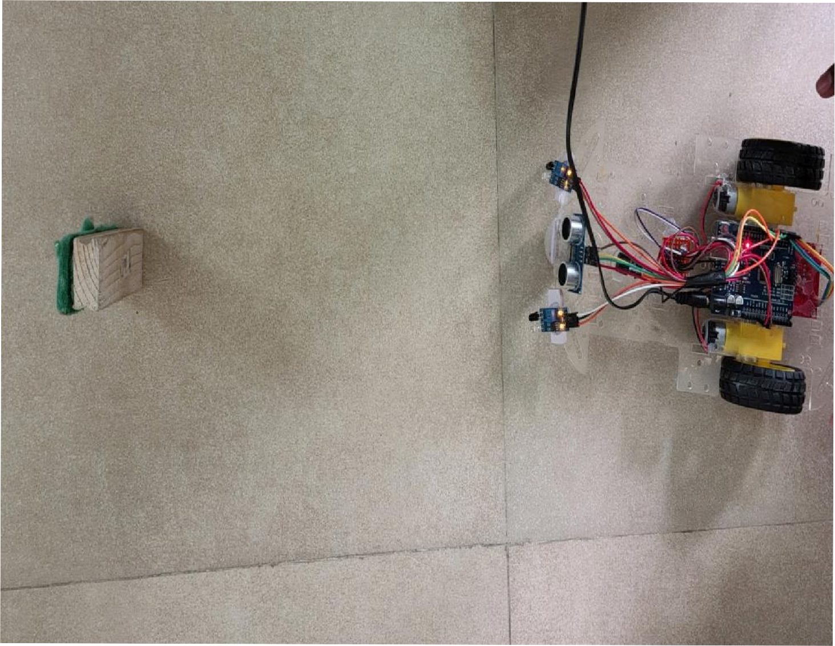

CONCLUSION

The Railway Crack, Track, and Obstacle Detection System provides an effective and reliable solution to improve railway safety by using embedded systems and sensor technology. The system successfully detects cracks and obstacles in real time using IR and ultrasonic sensors. Based on the sensor inputs, the Arduino microcontroller processes the data and takes immediate action by stopping the motor and activating a buzzer alert.
This project reduces the dependency on manual inspection and minimizes the chances of human error. It ensures continuous monitoring of railway tracks and provides quick response to any fault condition. The use of low-cost components makes the system affordable and easy to implement in real-world applications.
Overall, the project demonstrates how automation and embedded systems can significantly enhance railway safety and efficiency. The system achieves its objectives and proves to be a practical and reliable solution for accident prevention.

FUTURE SCOPE

The Railway Crack Detection System has significant potential for future improvements and enhancements. One of the major advancements can be the integration of Internet of Things (IoT) technology, which will enable remote monitoring and real-time data transmission to control centers.
The system can be further improved by incorporating GPS tracking, which will help in identifying the exact location of faults on the railway track. This will allow quicker maintenance and response from authorities.
Another enhancement can be the use of Artificial Intelligence (AI) and Machine Learning (ML) algorithms for advanced fault detection and prediction. These technologies can improve accuracy and enable the system to identify complex patterns in track conditions.
Additionally, features such as wireless communication, mobile application support, and solar power integration can be added to improve usability and efficiency. The system can also be scaled for large railway networks, making it suitable for real-time monitoring across long distances.

REFERENCES

      - Singh, R., & Verma, P., “Railway Track Crack Detection System Using Embedded Systems,” International Journal of Engineering Research and Technology (IJERT), 2017.
      - Arduino, “Arduino UNO Technical Specifications,” Available at: https://www.arduino.cc
      - Maheshwari, A., & Kumar, S., “Obstacle Detection System Using Ultrasonic Sensors,”
International Journal of Advanced Research, 2016.
      - IR Sensor Module Datasheet
      - Ultrasonic Sensor (HC-SR04) Datasheet
      - Various online tutorials and educational resources related to embedded systems and Arduino programming.

